**Assignment No:3**

Date of Assignment Given: Date of Submission:

Date of return after Evaluation:

**For all**

Outline the use of IOT devices in Embedded System

**Title/ Questions:**

1. Find out the average waiting time and average turnaround time for the following processes when applying
   1. FCFS
   2. LCFS
   3. SJF
   4. Round robin (time slice 3ms)

|  |
| --- |
|  |

Find average waiting time and average turnaround time

1. Find out the average waiting time and average turnaround time for the following processes when applying
   1. FCFS
   2. LCFS
   3. SJF
   4. Priority scheduling
   5. Round robin (time slice 3ms)

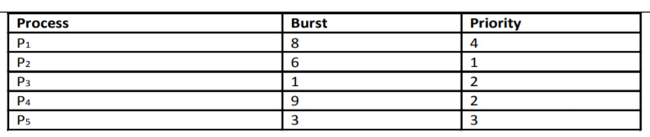

1. Find out the average waiting time and average turnaround time for the following processes when applying
   1. FCFS
   2. LCFS
   3. SJF
   4. Priority scheduling
   5. Round robin (time slice 2ms)

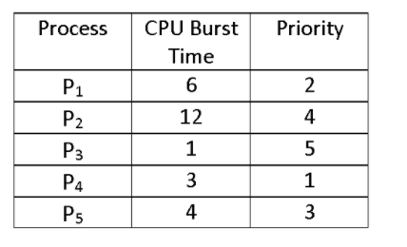

Name of the Faculty & Signature